Catechesis of the Good Shepherd
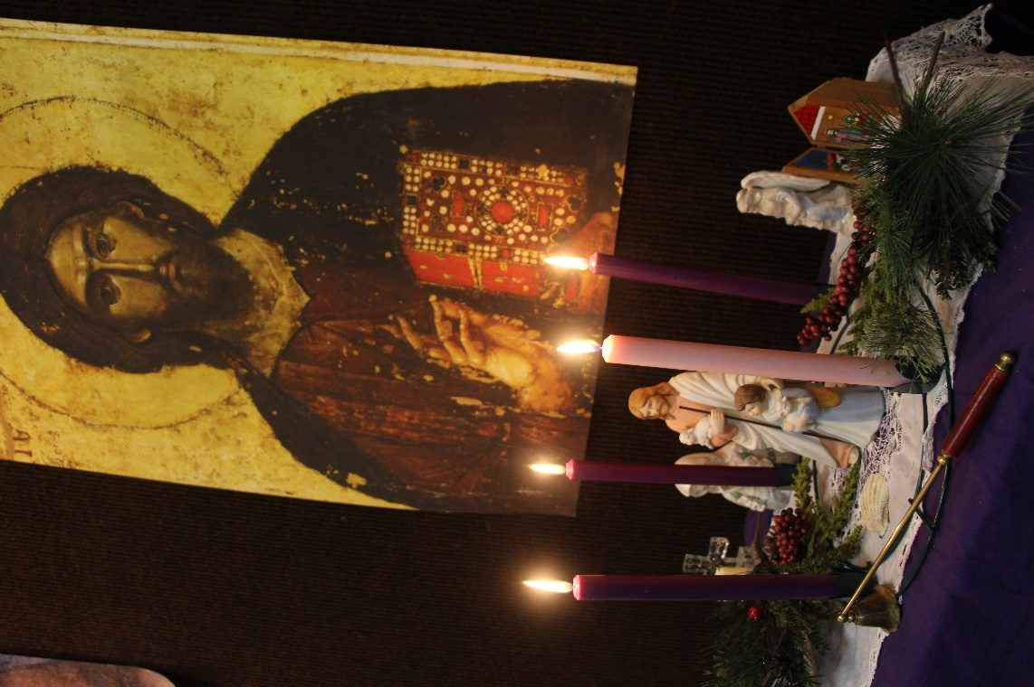
Advent Session Nov.8- Dec. 18 2019 5:30- 6:30 p.m.
St. Dunstan’s Episcopal Church
918-492-7140

Children ages 3-6 are invited to join The Good Shepherd as we journey through Advent
Any child is welcome to join us in our atrium this year as we explore the season of Advent, from the stories of the prophets to the birth of Jesus.
St. Dunstan’s is proud to offer this gentle and joyful program, which is free to any child between the ages of 3-6 years.
Catechesis of the Good Shepherd is designed to help children grow in their relationship with God through deep engagement in scripture and liturgy, using the concepts of the Montessori education method.
Catechesis of the Good Shepherd is based on the belief that the child and God are already in a relationship, and our role is to provide a safe place for that relationship to grow. During our Advent session, children will be introduced to The Good Shepherd, and begin building a foundation for understand what the season of Advent means—how we are watching and waiting for “The Great Light”, and the celebration when that light finally appears in the world.
St. Dunstan’s Episcopal Church Tulsa, Oklahoma Stduntulsa.org
This Advent season we will be learning about the geography of the land of Israel, complete with finding the cities of Nazareth, Bethlehem, and Jerusalem; exploring the wisdom of the prophet Isaiah, as well as exploring in depth the stories of The Annunciation and The Adoration of the Shepherds.
As the child works in the atrium, they will also practice fine motor skills, social graces, and be allowed to enter into a state of concentration that leads to contemplation—the beginnings of their prayer life.
If you have any questions about this program, please feel free to contact our children’s catechist, Heather Sleightholm at sleightholmfolk@yahoo.com
Please note that YOU DO NOT have to be Episcopalian to participate in this atrium. All are welcome!
To enroll your child in the Advent session, please fill out the form below and return to the parish office.
We will meet for atrium each week in the north lobby by the parish office, and then enter into the atrium space together. Because of this, it is very important to arrive on time for atrium at 5:30 p.m. Atrium will end at 6:30 p.m.
Parents are welcome to quietly observe if they wish. Please do not bring outside food, drink or toys.
Dinner is served for a small fee each Wednesday evening at 6 pm, and anyone is welcome to take part, just RSVP at the church office by Tuesday at noon. Children are welcome to join their parents at dinner in the parish hall after atrium. Church office Number: 918-492-7140
St. Dunstan’s Episcopal Church Tulsa, Oklahoma stduntulsa.org
Catechesis of the Good Shepherd Enrollment ADVENT SESSION
Child’s Name:______________________________________ Age:______ Grade:_______

Parent’s Name:___________________________ Phone Number:____________________

Address: _________________________________________________________________

Email: _____________________________________________

Emergency Contact: ________________________________ Phone: _____________

